PUBLIC UTILITIES COMMISSION OF THE STATE OF CALIFORNIA

Telecommunications Division | RESOLUTION T-16559
Public Programs Branch | August 23, 2001

R E S O L U T I O N

RESOLUTION T-16559. TO ADOPT THE BUDGET FOR THE TIME PERIOD FROM JULY 1, 2002 THROUGH JUNE 30, 2003 FOR THE TELECOMMUNICATIONS DEVICES FOR THE DEAF (TDD) PLACEMENT INTERIM COMMITTEE (TPIC).

BY LETTER DATED MAY 30, 2001.
_________________________________________________________________

SUMMARY

This resolution adopts an operating budget of $1,092,615 for the TDD Placement Interim Committee (TPIC), for the time period of July 1, 2002 through June 30, 2003. The resolution also reduces the current surcharge rate to zero effective July 1, 2002. A breakdown of the adopted budget is set forth in Appendix B.

BACKGROUND

Pursuant to Decision No. 97-12-104, effective December 16, 1997, the Commission established the TPIC to design and implement a program that provides for publicly available telecommunications devices capable of servicing the needs of the deaf or hearing impaired (program equipment) in existing buildings, structures, facilities, and public accommodations as required by Section 2881.2 of the Public Utilities Code. The TPIC is to be funded by an incremental surcharge of up to 0.0002, or 0.02%, applicable to the billing base to which the Deaf and Disabled Telecommunications Program (DDPT) surcharge is applied. The maximum funding limit for the DDTP surcharge (the aggregate of both the DDTP Program and the TPIC) is capped at 0.50%.

Subject to the direction, control, and approval of the Commission, the TPIC’s mission is to specify locations within existing buildings, structures, facilities and public accommodations for the placement of program equipment and to ensure consideration for the procurement, installation, and maintenance of the program equipment. The TPIC also serves as an advisory committee on issues related to meeting the requirements of Section 2881.2 of the Public Utilities (P.U.) Code.

Decision (D.) 99-03-034 adopted the budget for 1999 and funded the program through an incremental surcharge of 0.012% in the Deaf Equipment Acquisition Fund (D.E.A.F.) surcharge for bills rendered on or after January 1, 1999. This adopted incremental surcharge was applied on all bills for subscribers’ intrastate telephone service, other than one-way radio paging service and universal lifeline telephone service, as set forth in PU Code Section 2881 (d). The D.99-03-034 also states that subsequent budget and surcharge requests shall be submitted by letter to the Executive Director and served on the service list.

Resolution T-16362 adopted a year 2000 budget of $1,228,318 and reduced the surcharge rate from 0.012% to 0.001%. Resolution T-16403, adopted by the Commission on May 18, 2000, authorized a budget of $586,338 for the six- month period of January 1, 2001 through June 30, 2001, and continued the same surcharge rate. The same surcharge rate also was continued in Resolution T-16429 for the $464,179 budget for fiscal year 2001-2002.

BUDGET FILING PROCESS

The provisions of P.U. Code Section (Section) 279 (b) changed the filing requirements for TPIC budgets and surcharge levels and provided that TPIC Program funds be deposited to the State Treasury. To conform to the State Budget process, the TPIC budget process was modified from a calendar year basis to a State of California fiscal year budget basis.

To comply with the requirements of P.U. Code Section 273 (a), the TPIC Administrative Committee must submit a proposed budget through a letter request to the Commission on or before June 1. The Commission has ninety (90) calendar days to approve the proposed TPIC budget since the Commission must submit a Budget Change Proposal for the TPIC Program to the Department of Finance (DOF) by September 1.

Furthermore, P.U. Code Section 274 includes a provision that requires the Commission to conduct a financial and compliance audit of public programs’ related costs and activities at least once every three years, beginning January 1, 2000. In future years under the provisions of P.U. Code Section 270 (b), if the State budget, which includes the TPIC Program budget expenses, is not adopted by the Legislature and signed by the Governor on or before the beginning of the fiscal year, any TPIC related expenses will not be paid even if the associated expenses are approved by the TPIC Administrative Committee.

The PSPE budget for the fiscal year July 1, 3003 through June 30, 3004 should be submitted to the Commission’s Executive Director on or before June 1, 2002.

NOTICE/PROTESTS

On May 30, 2001, the TPIC Program submitted to the Commission its proposed budget of $360,629 for the time period from July 1, 2002 through June 30, 2003. This filing was publicly noticed on the Commission’s Daily Calendar on July 12, 2001 stating that any responses and/or protests must be made in writing and received by the Commission within 20 days. The Telecommunications Division (TD) will incorporate any comments received on a timely basis.

DISCUSSION

TPIC requested a budget of $360,629 for the 2002/2003 fiscal year which is approximately $103,000 less than the budget for the current fiscal year 2001/2002. The requested amount, however, doesn’t include the cost of $732,615 to purchase Text Teletype (TTY) equipment which was authorized in the prior budget year and for which funds have been earmarked. TD recommends that the $732,615 be added to the TTY equipment expense.

TD estimates that the reserve balance available at the end of fiscal year 2003, without any surcharge revenue, will be $1,176,615 as set forth in Appendix B. This amounts to over four months of operating expenses. TD recommends that the current surcharge should be reduced to zero effective July 1, 2002.

Regarding personnel, TPIC suggests one modification to the current staffing. TPIC requests that the assistant manager position work full time on the TPIC program and not be allocated to the other two payphone programs. Given the large task of equipping buildings, where needed, throughout the state, to assure that the deaf and hard of hearing members of the public can access the public telephone network, TD believes it reasonable for the assistant manager to work full time on this program. TD recommends adopting the positions, base annual salaries and allocations of annual salaries for the 2002-2003 fiscal year as are described on Appendix A.

We note that the budget for Personnel and other administrative expenses is likely to change because of the need to transition TPIC funds to the State Treasury pursuant to Section 270,which was added by Senate Bill (SB) 669 (Polanco 2000). Once TPIC funds are moved to the State Treasury, we expect that the TPIC program will need to be internalized at the Commission. This internalization of the program may occur in the 2001-2002 fiscal year. We await approval of the 2001-2002 fiscal year. We await approval of the 2001-2001 State budget to know the precise impact of internalization on the TPIC budget. If the budget is approved in time, we may amend this resolution to reflect the changes resulting from internalization.

NOTICE OF AVAILABILITY OF CONFORMED RESOLUTION

In the past the Commission has served hard copies of resolutions on carriers and parties on the appropriate service list(s). To be consistent with the Commission’s commitment to utilize the CPUC Internet for distributing Commission orders and information, TD has sent a letter of notice to the parties of record in I. 88-04-029 as well as the Local Exchange Carriers (LECs) and the Competitive Local Exchange Carriers (CLECs) informing them of the availability of the draft resolution as well as the conformed resolution, when adopted by the Commission, on the Commission website, www.cpuc.ca.gov. In addition, a hard copy of the draft resolution in this matter was sent to the parties of record in I. 88-04-029 on July 24, 2001. Comments received on a timely basis will be addressed by TD in this resolution. A copy of the conformed resolution also will be provided to all parties on the service list of I. 88-04-029
.

All LECs and CLECs that provide a line for a pay telephone should file an advice letter with associated tariff sheets revising the TPIC surcharge on or before June 15, 2002, consistent with the provisions of General Order No. 96-A. The notice requirement of G. O. 96-A, Section III, G.1, (to furnish competing utility companies, either public or private, with copies of the related tariff sheets), should be waived. The advice letter and tariff sheets should become effective on July 1, 2002.

For administrative efficiency, it is reasonable to allow all LECs and CLECs that collect various public program charges, for Fiscal Year 2002-2003, to file one advice letter, accompanied by associated tariff sheets, revising the surcharge rates in accordance with commission adopted resolutions and/or decisions.

FINDINGS

- SB 669 changes the filing requirements for proposed public program budgets and surcharge rates to a fiscal year basis from a calendar year basis.

- TD’s recommended budget of $1,092,615 for the fiscal budget period of July 1, 2002 through June 30, 2003, as set forth in Column D of Appendix B, is reasonable and should be adopted.

- The TPIC Program positions and salaries set forth in Appendix A are reasonable and should be adopted.

- TD’s recommendation that the current surcharge should be reduced to zero due to sufficient available reserves to cover expenses without any surcharge funding the fiscal year beginning July 1, 2002 and ending June 30, 2003 is reasonable and should be adopted.

- All LECs and CLECs that provide a line for a pay telephone should file an advice letter with associated tariff sheets revising the TPIC surcharge on or before June 15, 2002, consistent with the provisions of General Order No. 96-A. The notice requirement of G. O. 96-A, Section III, G.1., (to furnish competing utility companies, either public or private, with copies of the related tariff sheets), should be waived. The advice letter and tariff sheets should become effective on July 1, 2002.

- For administrative efficiency, it is reasonable to allow all LECs and CLECs that collect various public program charges, for Fiscal Year 2002-2003, to file one advice letter, accompanied by associated tariff sheets, revising the surcharge rates in accordance with commission adopted resolutions and/or decisions.

- The PSPE budget for the Fiscal year July 1, 2003 through June 30, 2004, should be submitted to the Commission’s Executive Director on or before June 1, 2002.

THEREFORE, IT IS ORDERED that:

- The Telecommunications Devices for the Deaf (TDD) Interim Placement Committee (TPIC)’s annual budget from July 1, 2002 through June 30, 2003 of $1,092,615 as set forth in Column D of Appendix D is adopted.

- The TPIC Program positions and salaries set forth in Appendix A are adopted.

- The TPIC surcharge rate is reduced to zero, effective July 1, 2002.

- All LECs and CLECs that provide a line for a pay telephone must file an advice letter with associated tariff sheets revising the TPIC surcharge on or before June 15, 2002, consistent with the provisions of General Order No. 96-A. The notice requirement of G. O. 96-A, Section III, G.1., (to furnish competing utility companies, either public or private, with copies of the related tariff sheets), is waived. The advice letter and tariff sheets shall be effective on July 1, 2002.

- For administrative efficiency, it is reasonable to allow all LECs and CLECs that collect various public program charges, for Fiscal Year 2002-2003, to file one advice letter, accompanied by associated tariff sheets, revising the surcharge rates in accordance with commission adopted resolutions and/or decisions.

- The TPIC budget for the fiscal year July 1, 2003 through June 30, 2004 shall be submitted to the Commission’s Executive Director on or before June 1, 2002.

This Resolution is effective today.

I hereby certify that this Resolution was adopted by the Public Utilities Commission at its regular meeting on August 23, 2001. The following Commissioners approved it:

WESLEY M. FRANKLIN

Executive Director

APPENDIX A

The following are the adopted positions, base annual salaries and allocations of annual salaries

for the 2002-2003 fiscal year TPIC program. All but one of the total salaries are proportionately allocated to other payphone program functions separate from the TPIC. These percentage allocations are described in the footnotes associated with the following tabulation of salary expenses.

Positions | Adopted Annual Salary | Total Salary
Director (1) | $73,856 | $ 14,7711
Office Assistant (1) | $39,314 | $3,9312
TPIC Assistant Manager | $56,485 | $56,6933
Inspectors (8) | $40,918 | $32,7344
Field Supervisor (1) | $44,023 | $8,8045
 | TOTAL | $116,933

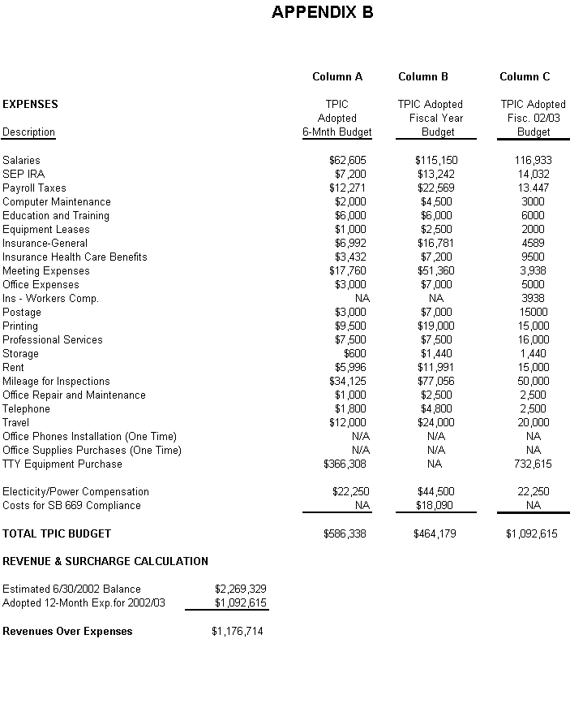
STATE OF CALIFORNIA Gray Davis, Governor
PUBLIC UTILITIES COMMISSION
505 VAN NESS AVENUE
SAN FRANCISCO, CA 94102-3298

July 24, 2001

To: All California Public Utilities Commission Certificated Telecommunications Carriers

The following draft Resolutions will be on the agenda of the Commission’s August 23, 2001 meeting:

A) Draft Resolution T-16550 proposes the approval of the following:
- The California High Cost Fund-A program budget for July 1, 2002 to June 30, 2003 in the amount of $ 43. 250 million.
- The increase in the surcharge rate to 0.210% effective July 1, 2002 from the current surcharge rate of 0.20%.

Draft Resolution T-16554 proposes the approval of the following:

The California High Cost Fund-B program budget for July 1, 2002 to June 30, 2003 in the amount of $ 563.425 million.
  - The maintenance of the current 2.6% surcharge rate.

Draft Resolution T-16548 proposes the approval of the following:

The California Teleconnect Fund program budget for July 1, 2002 to June 30, 2003 in the amount of $ 57.125 million.
  - The increase in the surcharge rate to 0.31% effective July 1, 2002 from the current surcharge rate of 0.185%.

- Draft Resolution T-16561 proposes the approval of the following:
  - The Universal Lifeline Telephone Service program budget for July 1, 2002 to June 30, 2003 in the amount of $ 284.012 million.
  - The decrease in the surcharge rate to 1.25% effective July 1, 2002 from the current surcharge rate of 1.45%.

Draft Resolution T-16546 proposes the approval of the following:
  - The implementation of the 711 abbreviated dialing code for the California Relay Service (CRS).
  - Modification of the definition of basic service to include access to CRS via 711.
  - Adoption of signage requirements for payphones to implement 711.

- Draft Resolution T-16559 proposes approval of the following:
  - The Telecommunications Devices for the Deaf Placement Interim Committee (TPIC) program budget for July 1, 2002 to June 30, 2003 in the amount of $1.093 million.
  - The decrease in the surcharge rate to 0.00% effective July 1, 2002.

A copy of the draft resolutions are available to the public at the Commission’s web-site at www.cpuc.ca.gov/static/industry/telco/resolutions/index.htm. This Notice of Availability of the draft resolutions also informs you of the availability of the conformed resolutions, when adopted by the Commission, at the same website. Hard copies of the draft resolutions are being mailed to the following:

  - Draft Resolution T-16550: 17 Small LECs, CHCF-A Administrative Committee, and parties of record in I. 87-11-033.
  - Draft Resolution T-16554: Parties of Record in R.95-10-020/I.95-01-021.
  - Draft Resolution T-16548: Parties of Record in R.95-10-020/I.95-01-021.
  - Draft Resolution T-16561: Parties of Record in R.98-09-005/I.95-01-020/021.
  - Draft Resolution T-16546: Parties of Record in R.00-05-001, I.87-11-031, R.95-01-020, and participants in the April 11, 2002 workshop.
  - Draft Resolution T-16559: Parties of Record in I.88-04-029.

If you are not a party to the proceeding, and you do not have Internet access, you may obtain a copy of the draft resolutions or conformed resolutions by contacting the Telecommunications Division at (415) 703-1638.

Pursuant to Public Utilities (PU) Code 311 (g), these draft resolutions are available for public comments. Comments should be focused on factual, legal, and/or technical errors in the draft resolution. Comments must be limited to five pages in length and shall include a subject index listing the recommendations to the draft resolution, a table of authorities, and an appendix setting forth the proposed revised findings and ordering paragraphs.

These draft resolutions will be on the agenda of the Commission’s August 23, 2001 meeting which is to be held 30 days from the above mailing date. The Commission may vote on these resolutions, or it may postpone a vote until later. When the Commission votes on a draft resolution, it may adopt all or part of it as written, amend, or modify it, or set it aside and prepare a different resolution. Only when the Commission acts does the resolution become binding on the parties.

Comments on Resolutions T-16550, T-16554, T-16548, T-16561, T- 16546, and
T-16559 should be addressed as stated below. The date of submission is the date the comments are received by the Telecommunications Division. Parties must serve
a copy of their comments on each party set forth on the service list attached to the draft resolution, on the same date that the comments are submitted to the Telecommunications Division.

Comments must be received no later than August 8, 2001 (which is 15 days from the date of this mailing). Reply comments may be submitted on or before August 13, 2001 (5 days after opening comments are submitted) and shall be limited to identifying misrepresentations of
law, fact, or condition of the record contained in the comments of other parties. Replies shall not exceed three pages in length and shall be submitted and served in the same manner as opening comments. Late-filed opening comments and/or reply comments will ordinarily be rejected.

However, in extraordinary circumstances, a request for leave to submit comments or replies late may be filed together with proposed comments/replies. An accompanying declaration under penalty of perjury shall be submitted setting forth all the reasons for the late submission.

Opening comments and reply comments on these resolutions, should be addressed to
Hassan Mirza and mailed to California Public Utilities Commission, Telecommunications Division, 505 Van Ness Avenue, San Francisco, CA 94102.

Sincerely,

/s/ JOHN LEUTZA
John M. Leutza
Director
Telecommunications Division

Enclosure (Draft Resolution and Service List):
- Draft Resolution T-16550: 17 Small LECs, CHCF-A Administrative Committee, and parties of record in I. 87-11-033.
- Draft Resolution T-16554: Parties of Record in R.95-10-020/I.95-01-021.
- Draft Resolution T-16548: Parties of Record in R.95-10-020/I.95-01-021.
- Draft Resolution T-16561: Parties of Record in R.98-09-005/I.95-01-020/021.
- Draft Resolution T- 16546: Parties of Record in R.00-05-001, I.87-11-031, R.95-01-020, and participants in the April 11, 2002 workshop.
- Draft Resolution T-16559: Parties of Record in I.88-04-029.

1 The adopted salary for the PSPE Program Director is $73,856. 70% of his time and salary ($51,700) is allocated to the PSPE Program. 20% ($14,771) is allocated to the TPIC Program and 10% ($7386) to the PPPP.
2 The adopted salary for the PSPE Office Assistant is $39,314. 80% ($31,618) is allocated to PSPE. TPIC and PPPP are allocated 10% each ($3,848).
3 The adopted salary for the TPIC Assistant Manager is $56,693. 100 % of this position is allocated to the TPIC budget.
4 The 8 inspectors work 85% for the PSPE program ($279,344); they work 10% (32,734) for TPIC and 5% ($15,266 for the PPPP program.
5 The field supervisor allocates 20% of his time to TPIC ($8,804); for PPPP5% ($2,201) and 75% ($33,236) to PSPE.
TPIC surcharge rate is part of the CRS surcharge rate.

